How to Make Oobleck

Oobleck was the name given to a type of slime in a Dr. Seuss book that was capable of gumming up a whole kingdom. The oobleck that you can make for a science project isn't gummy, but it does have interesting properties of both solids and liquids. It normally behaves like a liquid or jelly, but if you squeeze it in your hand, it will seem like a solid.

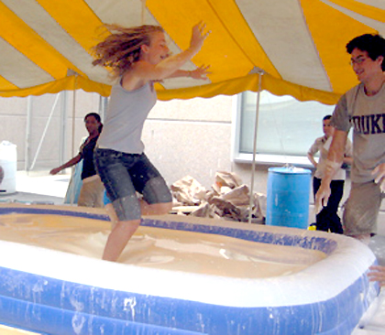

Difficulty: Easy

Time Required: 30 – 40 minutes

What You Need:
- water
- corn starch
- food coloring (optional)
- container

Here's How:
- Mix 1 part water with 1.5 to 2 parts cornstarch. You may wish to start with one cup of water and one and a half cups of cornstarch, then work in more cornstarch if you want a more 'solid' oobleck. It will take about 10 minutes of mixing to get nice homogeneous oobleck.
- Mix in a few drops of food coloring if you want colored oobleck.

Tips:
- Oobleck is a type of non-Newtonian fluid called a dilatant.
- If you slowly lower your hand into oobleck, it will sink, but it is difficult to quickly remove your hand (without taking all the oobleck and its container with you).
- If you squeeze or punch the oobleck, the starch particles will not move out of the way quickly, so the oobleck will feel solid.
- Oobleck can be molded in a container, but when the mold is removed, the oobleck will lose its shape.

